Reg no-21BCE1097

Name-Rishima Chowdhury

Fat Lab Software engineering.

Package Diagram

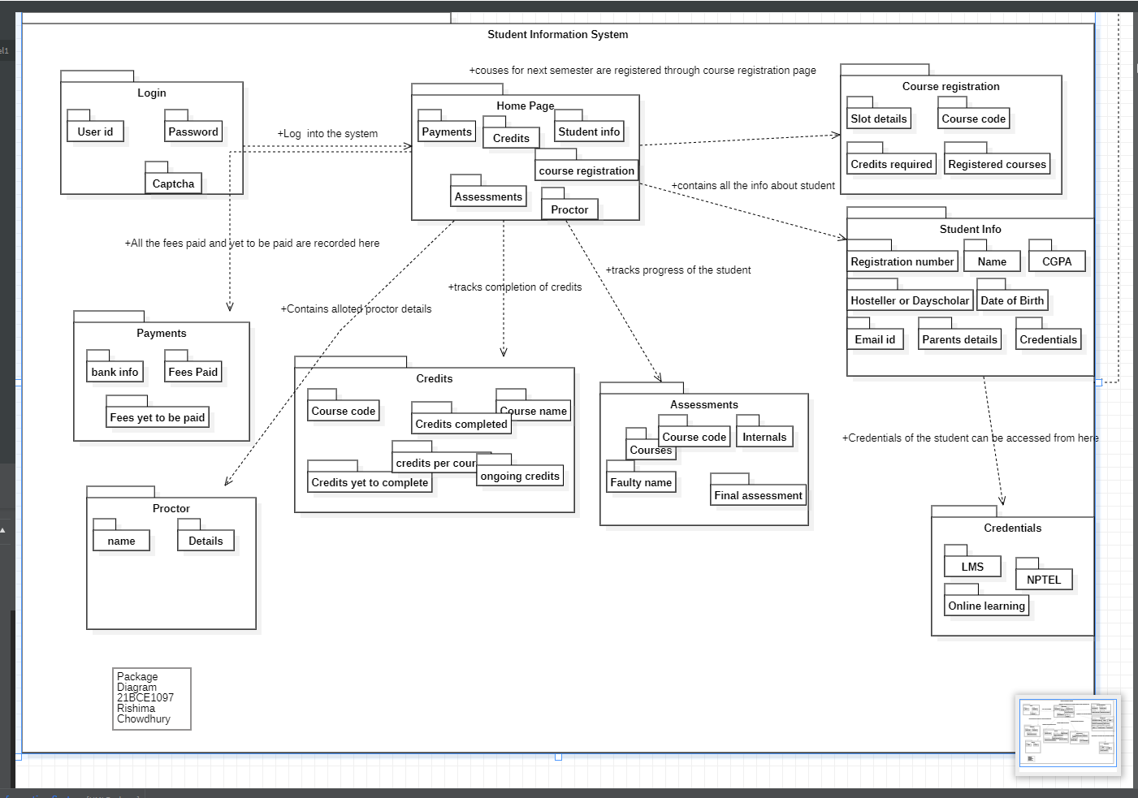

Deployment Diagram

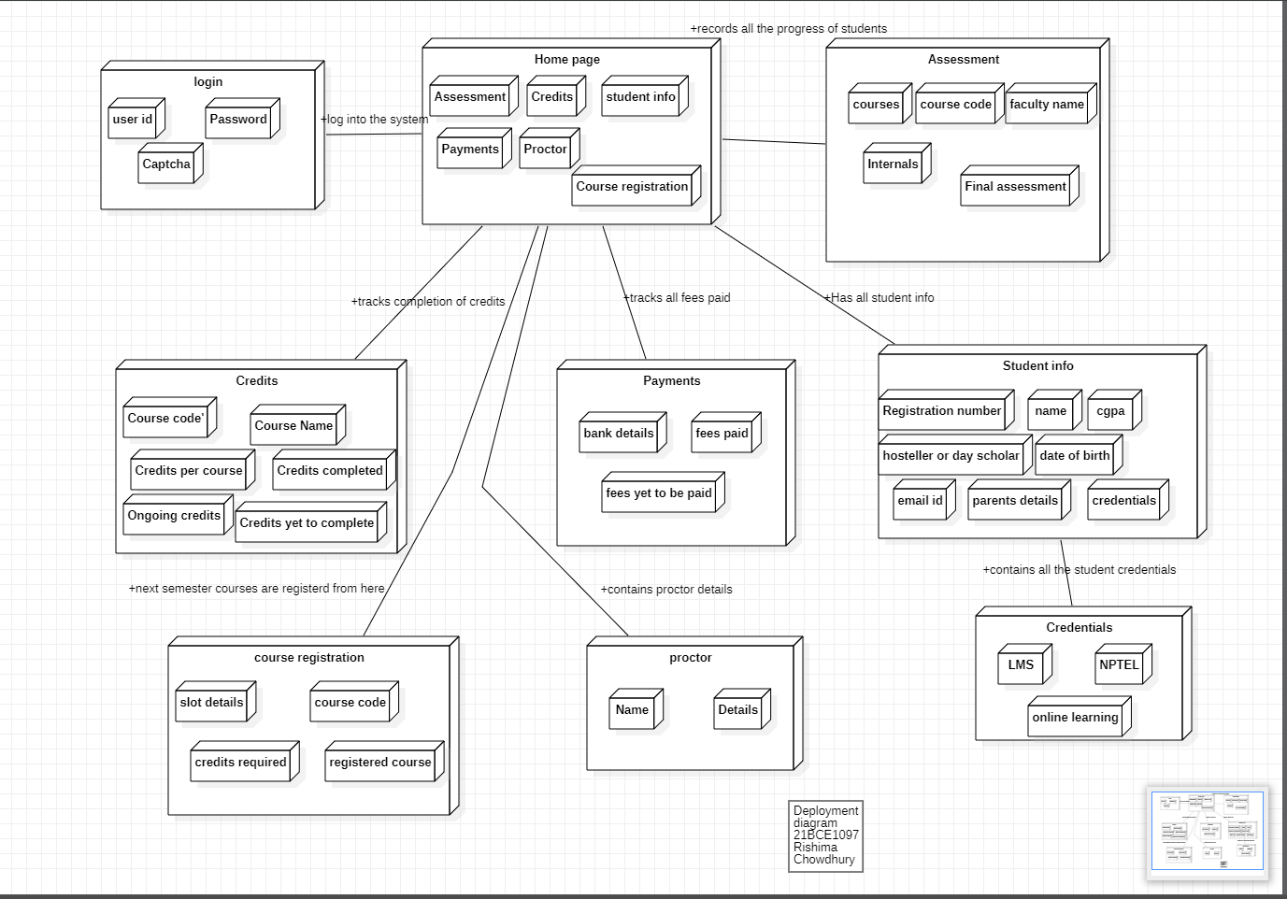

Component Diagram

